Particle Sample Submission Form
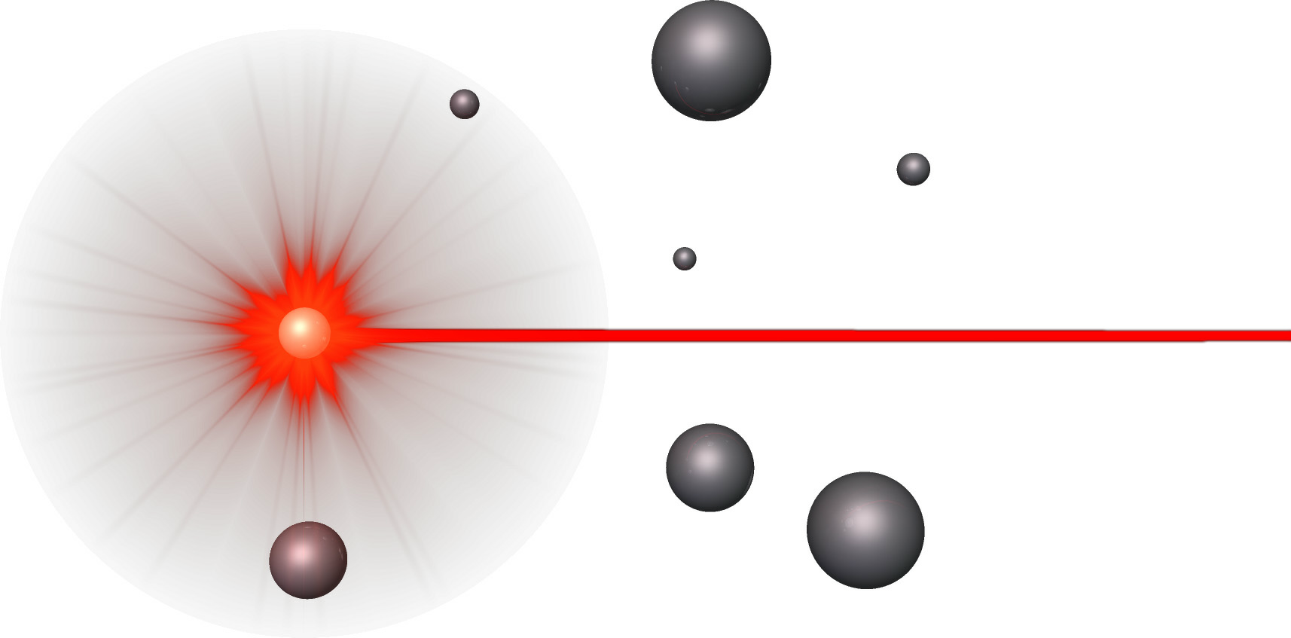
Characterization Laboratories, Inc.

PLEASE SIGN FORM AND INCLUDE YOUR PURCHASE ORDER OR PROCARD NUMBER WITH SAMPLES

COMPANY: | Complete Genomics, Inc.
Invoice Contact: |  |  |  |  | Contact: | Dr. Norman Burns
Address: |  |  |  |  | Address: | 750 North Pastoria Ave.
City, State, ZIP: |  |  |  |  | City, State, ZIP: | Sunnyvale, CA, 94085
E-mail: |  |  |  |  | E-mail:
Phone: |  |  |  |  | Phone: | (408) 431-6007
Fax: |  |  |  |  | Fax:
Quote#: |  |  |  |  | Signature:
 | (if applicable) |  |  |  |  | REQUIRED
PO/Credit Card#: |  |  |  |  | Industry Type:
Card Exp. Date: |  |  |  |  | Sample Type:

Card Signature:

Special Invoice Instructions
Is this a cGMP Project? |  |  | YES | NO | Is this a Litigation Case? |  | YES | NO
SAMPLE TYPE |  | SAMPLE ID# |  |  | # of  SAMPLES |  | ANALYSIS REQUESTED | CLASSIFICATION:  Normal  Hazardous*  (MSDS Required)  STORAGE:  Ambient  Refrigerator  Freezer  Light Sensitive
PLEASE INCLUDE MSDS WITH SAMPLES WHEN POSSIBLE

Special Sample or Data Reporting Instructions:
SAMPLE PRIORITY STATUS | Standard (e-mail data within 5 business days) |  |  |  |  | Rush not available for all analyses  Please call to inquire  Hardcopies of data will be FedEx Priority Overnight
SAMPLE PRIORITY STATUS | 100% Rush / 100% Surcharge  (e-mail data within 3 business days)
SAMPLE PRIORITY STATUS | cGLP / 100% Surcharge  (e-mail data within 10 business days)
Return Samples? | YES* NO |  | Additional $35 min. fee (FedEx Ground)  *MSDS Required for Hazardous samples–additional shipping charges may apply

